Assignment No: 10
Deploy a project from GitHub to EC2 by creating a new security group and user data.
Solution:
Step 1:
Upload required files to GitHub
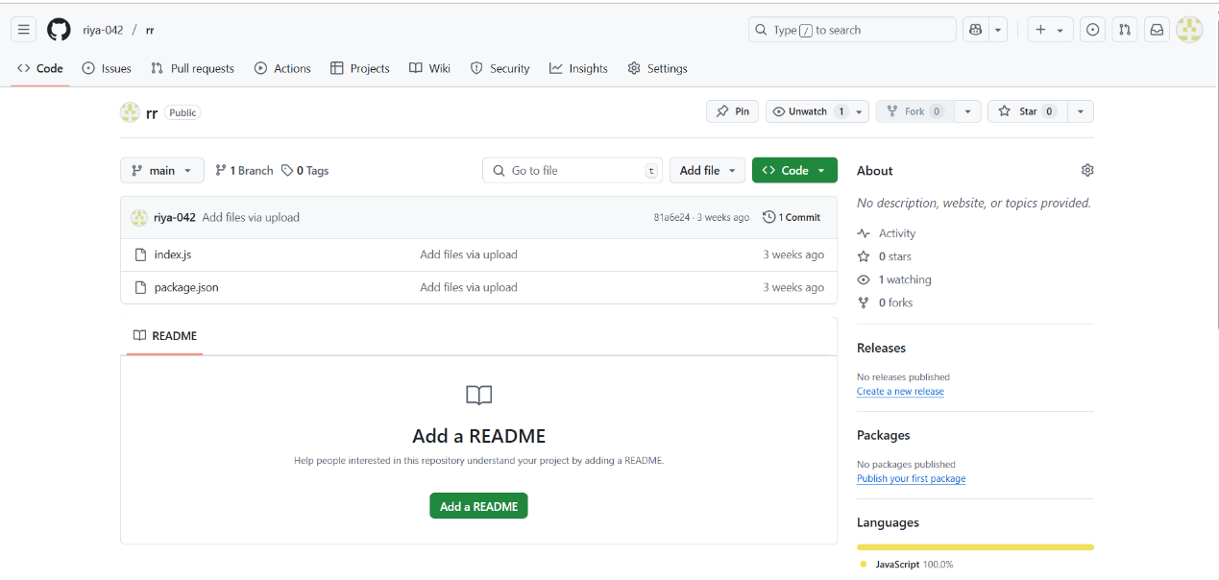
Step 2:
Log into AWS and open EC2. Click on launch instance. Give a name to the instance and select the operating system as Ubuntu.
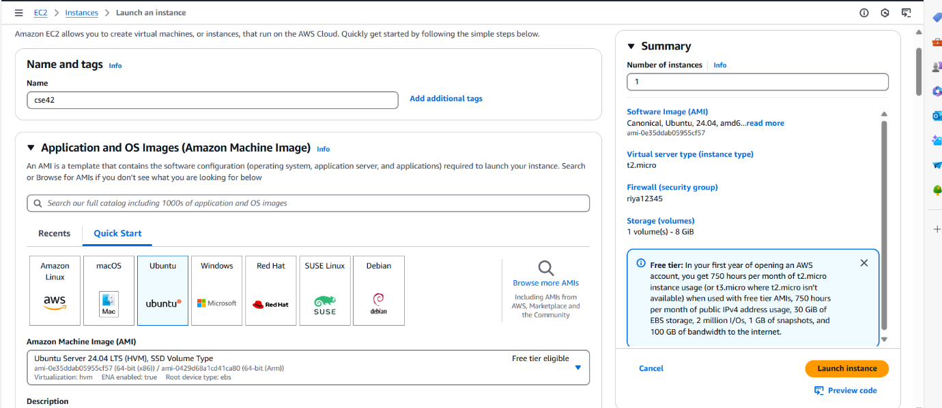
Step 3: Create Key Pair.
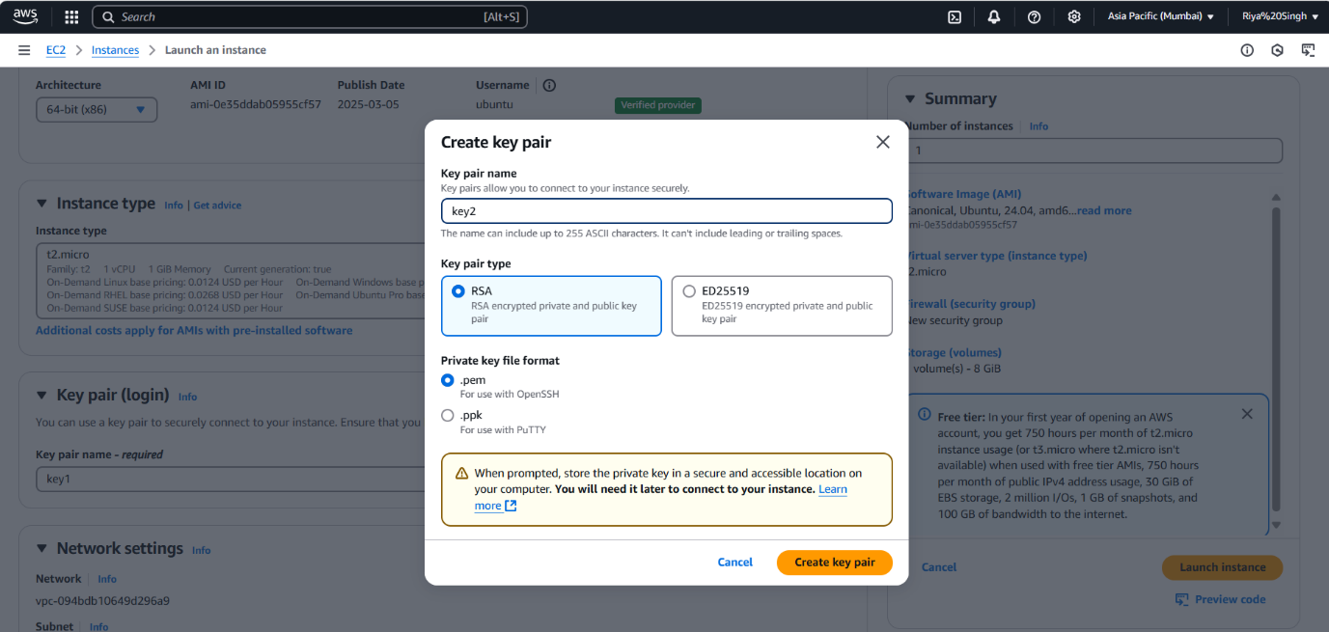
Step 4:
From the Network Section Select Existing Security Group then choose your previously created security group.

Step 5: After Selecting security group go to the user data section and write given cmd. and click launch instance.
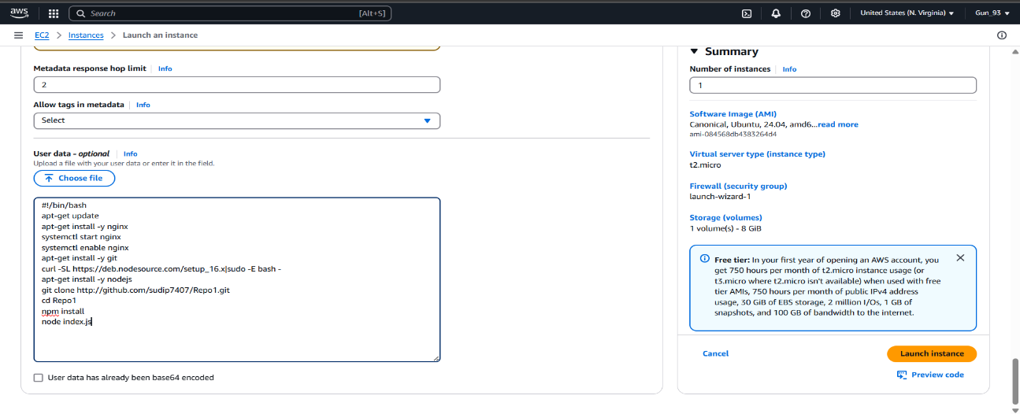
Step 6: Open instances and click of the instance Id of the instance. Copy the IPv4 address.
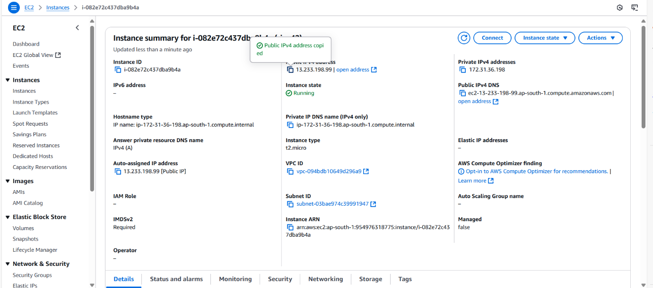
Step 7:
Open Bitvise SSH Client and paste the IP address in host and set up authentication using the key pair then login and after logging in open new terminal window.
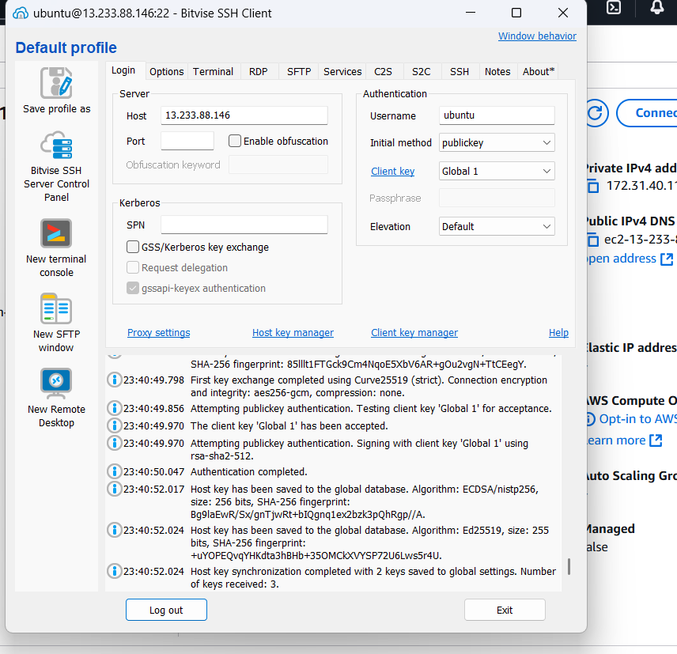
Step 8:
Now clone the GitHub repository from GitHub using command git clone paste the link of the repository. Now execute Sudo apt install node.js and npm install.
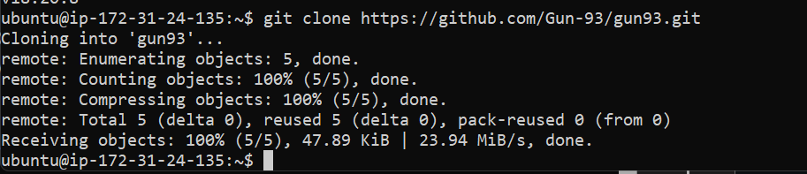
Step 9: Now open AWS and open the current instance then scroll down and go to security Section.
Then click on the link in security groups then click on edit inbound rules.
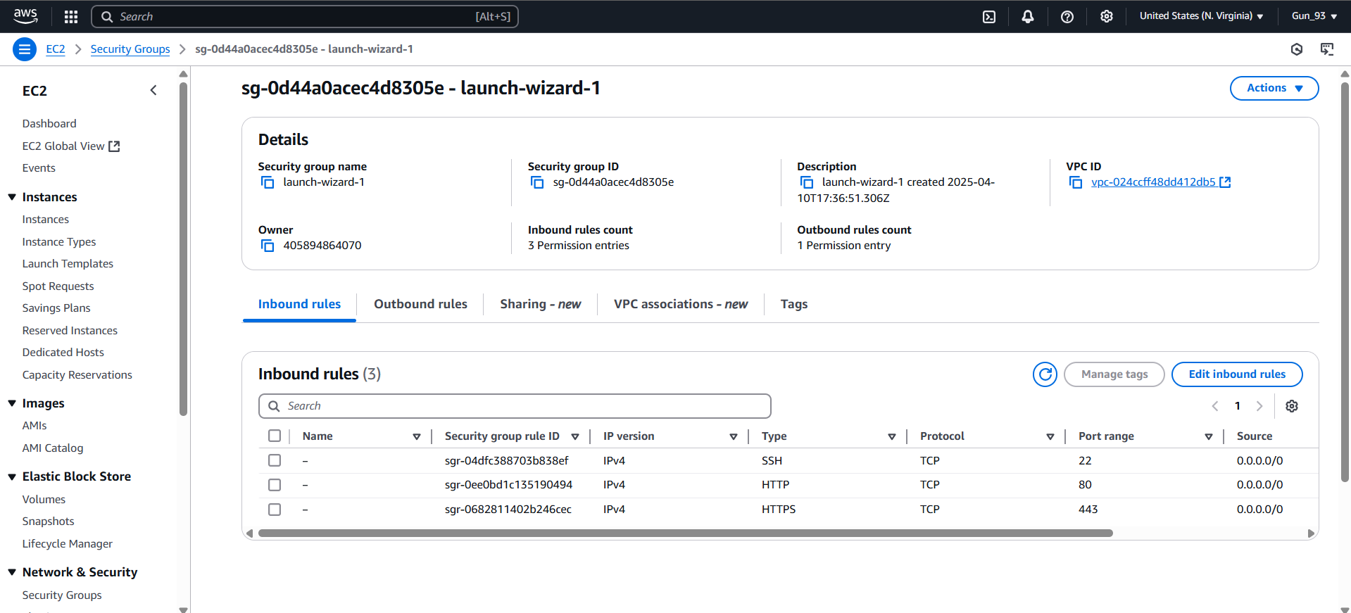
Step 10: Click on add rule and select the type of new rule custom TCP Port range 4000 source 0.0.0.0 or anywhere then click on save rule.
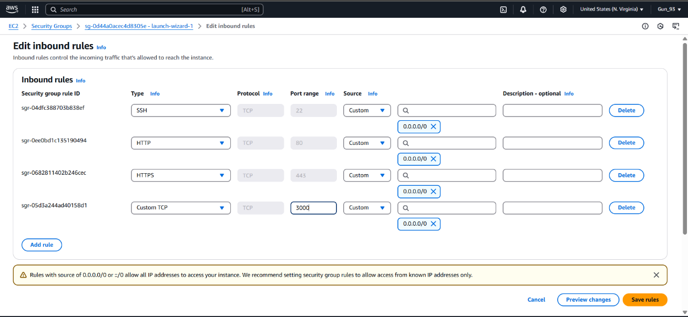
Step 11: Open the Bitvise SSH Client terminal console and start the server using command node index.js
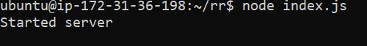
Step 12: Now copy the IPv4 address of the instance and paste it on web browser.
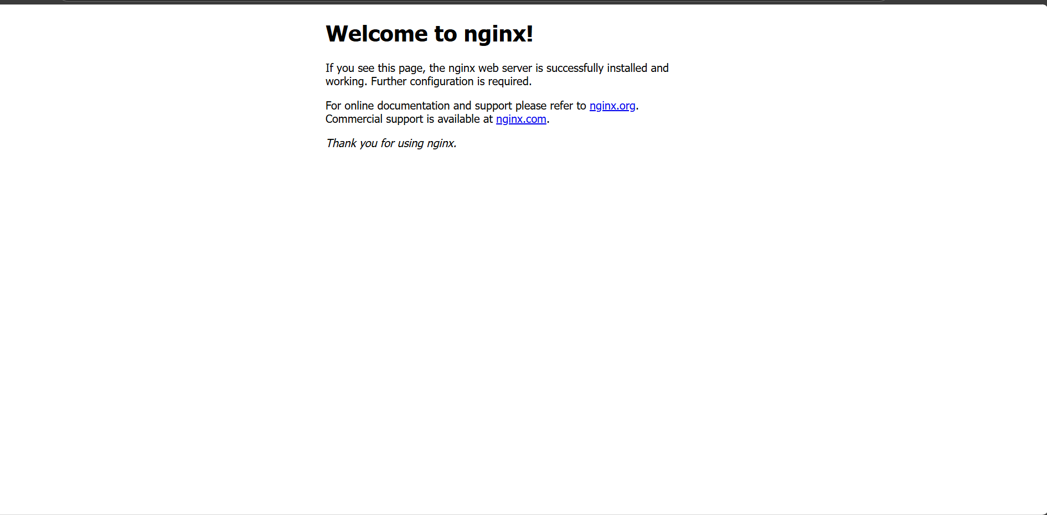
Step 13:
Then, put the port like this IP address:


